| PROJECT INFORMATION | | | |
| --- | --- | --- | --- |
| Report Description: | Literature review for EEG signals | | |
| Professor: | Prof. [Gady Agam](mailto:agam@iit.edu) | Tools used/work done: | 1. MatLab 2. EEGLab |
| Report prepared by: | [Noviya Balasubramanian](mailto:nbalasubramanian@hawk.iit.edu) |
| HAWK ID: | A20541236 |
| Report no: | 5 | Report Date: | 9/20/2024 |

Work done:

1. Got the data access.
2. Started the preprocessing technique with Xiaoting’s guidance

Classification of Motion States Using EEG Data Collected During a Virtual Construction Site Examination

Data: EEG exam data and training data

From the dataset of EEG signals we can classify 4 different states:

1. Active Tasking – In motion to do task
2. Response Mode – Answering the question
3. Cognitive Impasse – Confused or feeling stuck
4. Uncertain Response – Marking the answer as uncertain to answer

Classify between subjects in motion to do a task and when the subject is stuck and moving around the same place trying to solve, and eventually clicking “I’m stuck”.  
- Classify the intent of a person ignoring activity due to mental effort to move

Possible intent is to solve(aha! - find a ), move to give up(Impasse), Move to navigate; Consider the moment, before the move;

Add negative examples: Not solving or anything. Still!

* Classify - Impasse, Aha!, Uncertain, Some other task - to cover the other negative example
* What are standards of feature extraction? ANd signal representation - 1D, 2D matrix - Gai
* Using physiological signals such as the - HRV, Blink rate, pupil dilation, 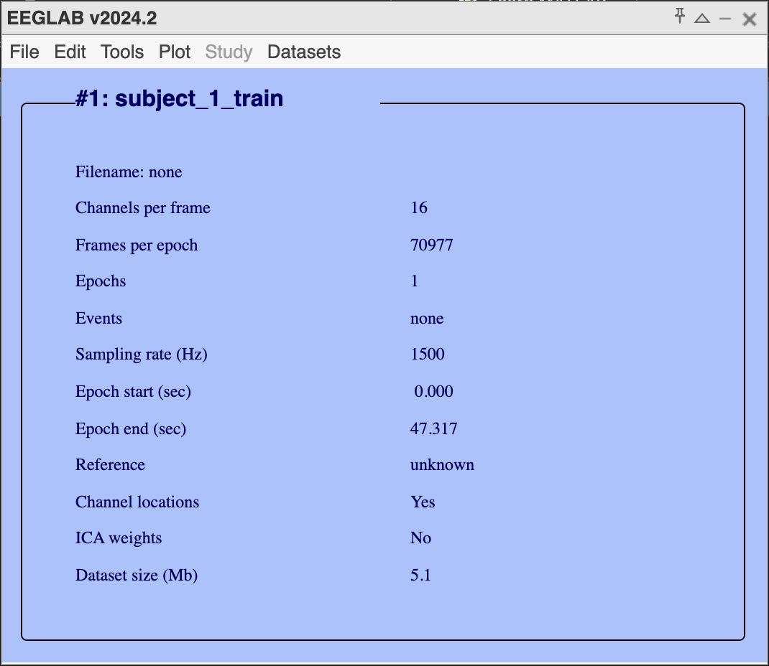
* Compare EEG to physiology, And both

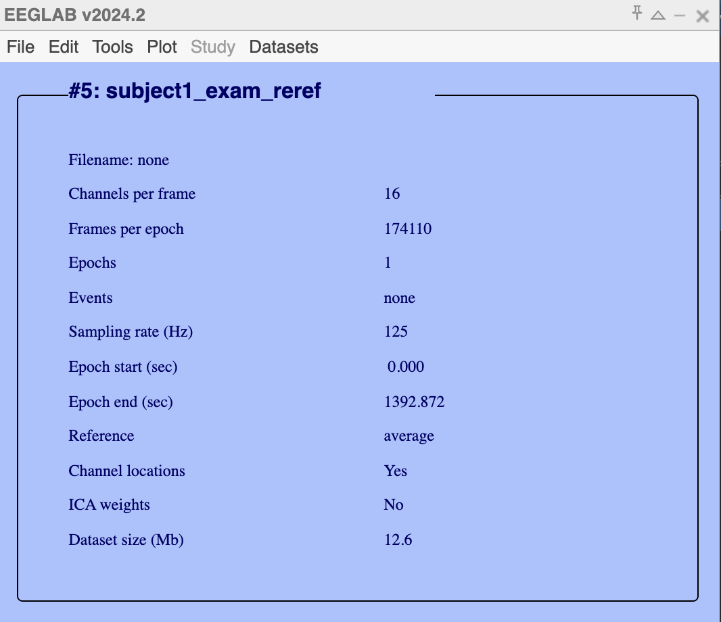

Preprocessing Procedure:

Channels: 16 electrodes

Sampling rate: 125 Hz

1.Convert .txt to .mat

2. Import Data to EEGLab

The converted .mat file was loaded into EEGLab, where the data from the 16 electrodes and the sampling rate of 125 Hz were specified. The electrode locations were also imported to ensure the spatial configuration was preserved.

3. Re-referencing the Data

The EEG data was re-referenced using the average reference method. This step involves adjusting the signals by averaging all electrode readings and subtracting this mean from each channel.

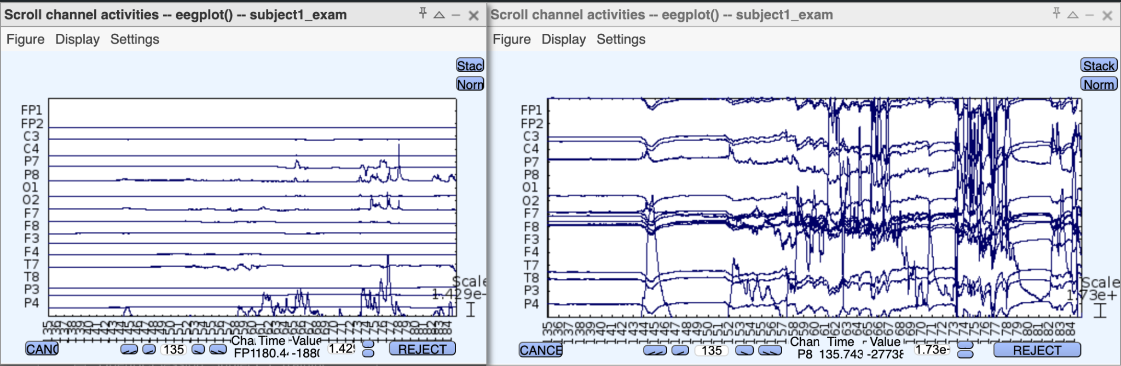

Note: Before re-referencing the most noisy data can be removed.

4. Step 4: Filtering the Data

A bandpass filter was applied to the data to remove noise and focus on the frequencies relevant to brain signals. The frequency range was set between 1-50 Hz, which captures most of the EEG signals while removing lower-frequency noise.

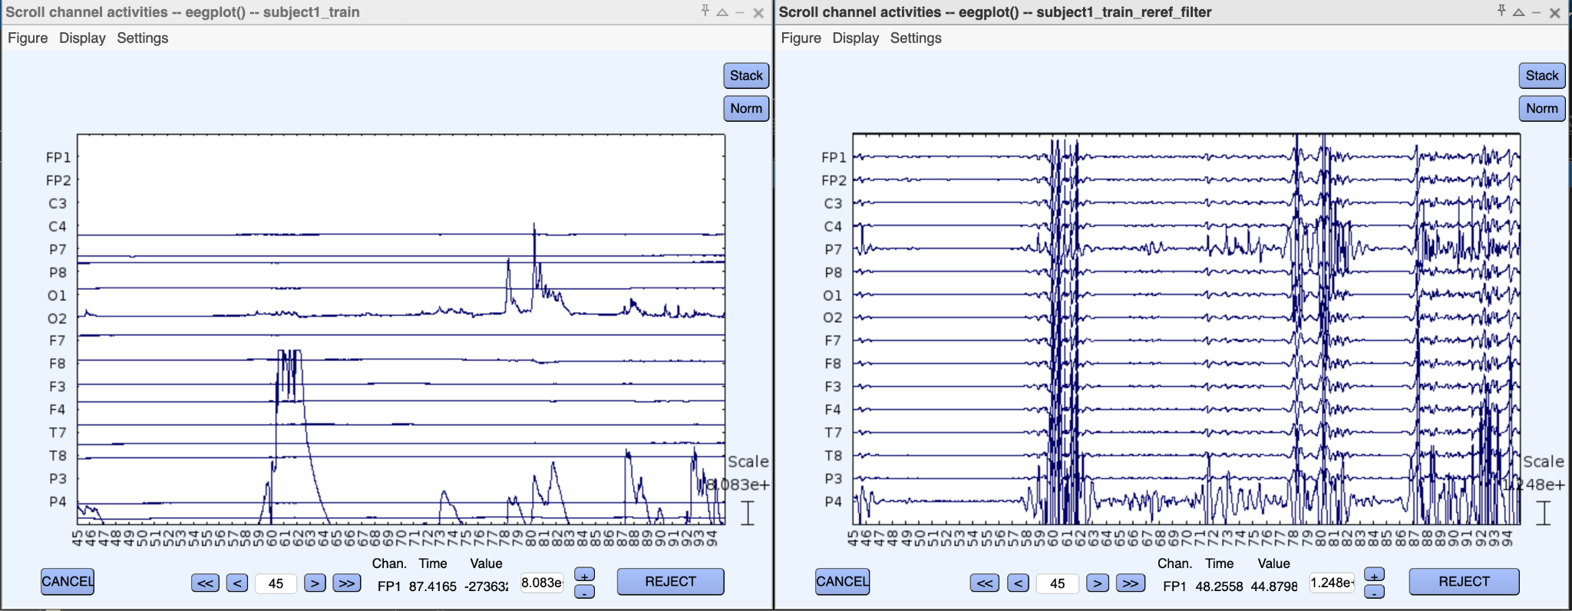

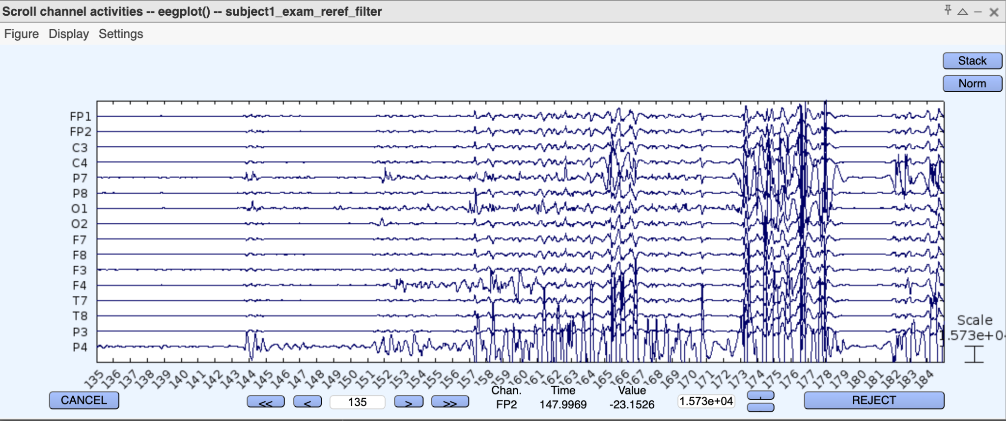

Note: Remove the Higher edge of the frequency pass band (Hz). Keeping 50 will remove higher-frequency artifacts (like muscle activity).

5. Decomposing with Independent Component Analysis (ICA)

ICA was performed to decompose the EEG signals into independent components. This process helps isolate artifacts (such as eye blinks, muscle movement, and electrical noise) from the neural signals. Unlike traditional filtering, ICA identifies the spatially fixed sources of artifacts and subtracts them, leaving the data clean while retaining the actual neural activity.

6. Inspecting the ICA Results

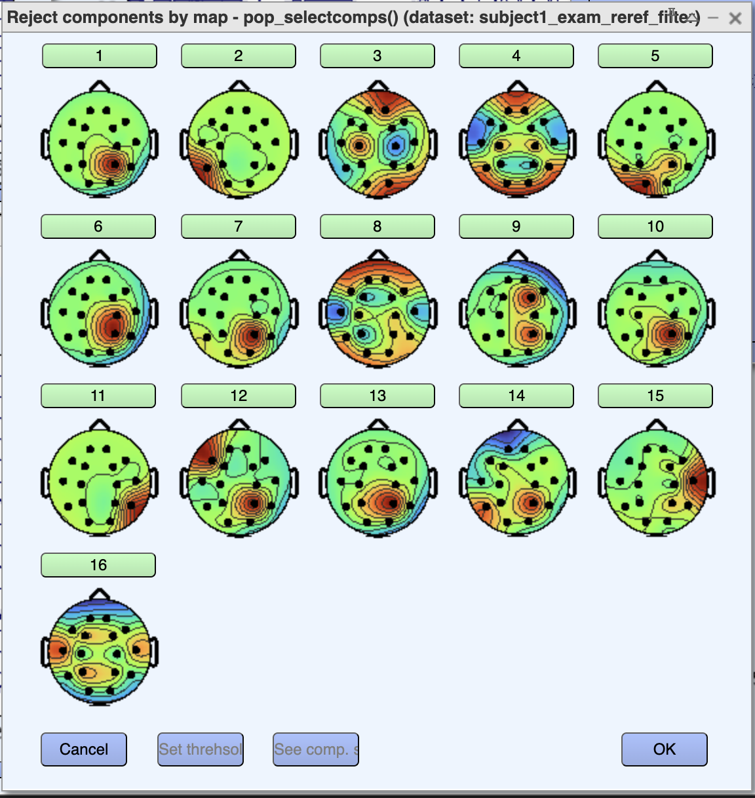 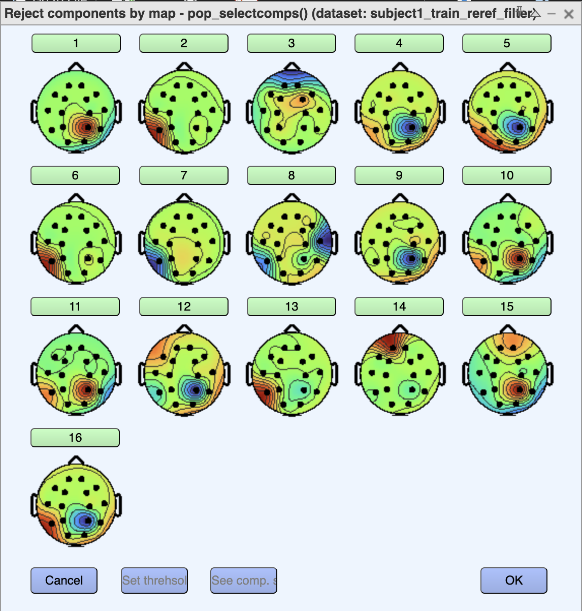

In [1], they captured eight features that are essentially statistical, fractal, and temporal properties of the EEG signal. By examining aspects like variability, frequency power, fractal irregularity, and temporal dynamics, these features enhance the classifier’s ability to distinguish cognitive states based on EEG data.

Key Steps in the Study:

EEG Data Collection: Acquired from ten healthy participants performing right and left-hand motor imagery tasks.

Preprocessing: EEG signals filtered using a band-pass filter, followed by ICA for removing ocular artifacts.

Feature Extraction: Various features such as variance, band power, and parameters like Hjorth and Barlow were extracted.

Dimensional Reduction: PCA reduces the dimensionality of the feature vector.

Classification: SVM, LDA, and MDC were used for classification, with SVM producing the highest accuracy.

In [2],

1. EEG signals are often mixed with EOG signals, which are larger in magnitude and lower in frequency. Traditional offline ICA methods like FastICA and Robust ICA are not suitable for real-time applications where EEG signals constantly evolve.

2. ORICA Algorithm: This algorithm performs independent component analysis in an online, recursive manner, which is computationally efficient and adaptable for real-time applications. Before applying the ICA algorithm to recording, the additive white Gaussian noise (AWGN) is added artificially to verify the separation effectiveness.The paper enhances this by applying a framework that includes preprocessing (e.g., band-pass filtering) and component selection, where EOG artifacts are separated from EEG signals.

>>Install BCILAB: ORICA is part of the BCILAB toolbox. (googled)

After the source separation, topographic maps are used to visualize and select the components that correspond to brain areas activated during motor imagery. These maps help distinguish between EEG and EOG sources effectively.

[3] Literature Comparison study

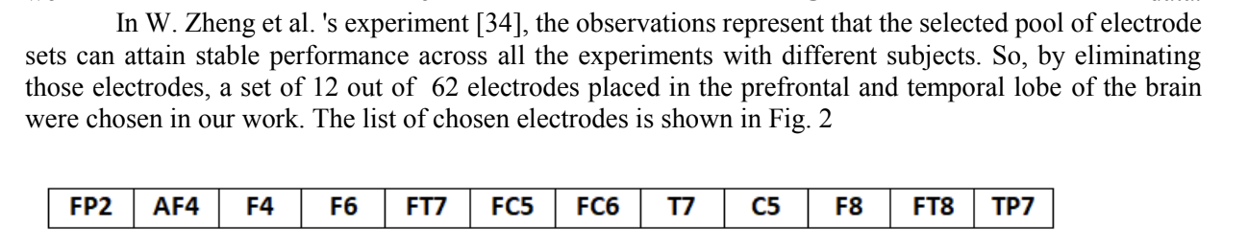

Todo:

1. Remove first and last few seconds before preprocessing; Remove electrodes;

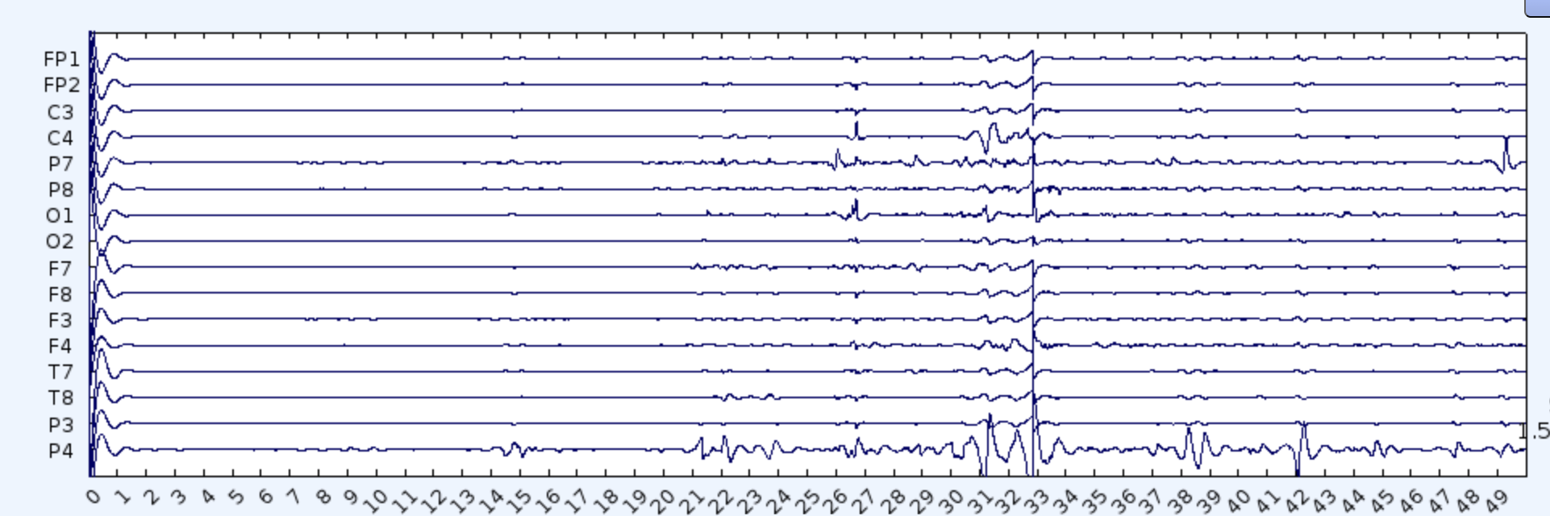

1. Use ICA to remove pupil movements and retain the muscle movements.
2. Understand ways to label the data

Ref:

[1]Y. Narayan, "Hand Motion Identification Based on EEG Signals Classification," 2021 2nd Global Conference for Advancement in Technology (GCAT), Bangalore, India, 2021, pp. 1-7, doi: 10.1109/GCAT52182.2021.9587556.

[2]X. Lin, L. Wang and T. Ohtsuki, "Online Recursive ICA Algorithm Used for Motor Imagery EEG Signal," 2020 42nd Annual International Conference of the IEEE Engineering in Medicine & Biology Society (EMBC), Montreal, QC, Canada, 2020, pp. 502-505, doi: 10.1109/EMBC44109.2020.9176484.

[3] N. Z. Zenia and Y. Hu, "Deep Learning Architectures Used In Eeg-Based Estimation Of Cognitive workload: A Review," 2021 IEEE International Conference on Autonomous Systems (ICAS), Montreal, QC, Canada, 2021, pp. 1-5, doi: 10.1109/ICAS49788.2021.9551143.

- <https://irenevigueguix.wordpress.com/2016/04/22/loading-openbci-datasets-in-eeglab/>

- https://eeglab.org/tutorials/06_RejectArtifacts/RunICA.html